

*During those days He went out to the mountain to pray and spent all night in prayer to God. When daylight came, He summoned His disciples, and He chose 12 of them--He appointed them apostles.*

*Luke 6:12-13*

Spring 2017

spri

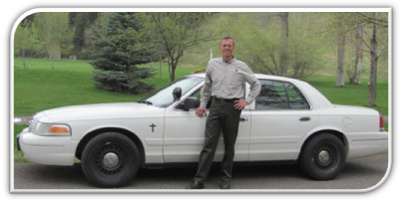

Braveheart Chaplain

Ministry

Teamwork is essential when it comes to accomplishing most sizeable tasks. Providing chaplain services to emergency responders, their families, and citizens in crisis throughout Flathead County is a monumental mission. Accomplishing a cause of this scope is possible only with a team.

Braveheart Chaplain Ministry is a team effort. All that Braveheart contributes to our citizens and responders is done so by people who are committed to this purpose. This joint effort includes our Board, volunteers, donors, and other chaplains.

The Board of Directors provides governance and fundraising. They oversee the policies, directions, and funding of the ministry. They meet regularly and labor together to assure that this ministry is properly guided and funded. This devoted team consists of:

* Travis Ahner, J.D.
* Lisa Bartholomew
* Laura Johnson
* Russ Kinzer
* Captain Doug Overman, Kalispell Police
* Captain Kirk Pederson, Kalispell Fire
* Dr. Pam Roberts, MD
* Dick Sine
* Kipp Tkachyk
* Ric Vander Ark

Susan Sharp is a new volunteer who accomplishes many administrative assistant duties, as well as providing follow up with women who have experienced a crisis.

Another essential group of team members consists of donors, without whom the ministry would have no funding and would not exist. To all of you who give generously, a Montana-size thank you.

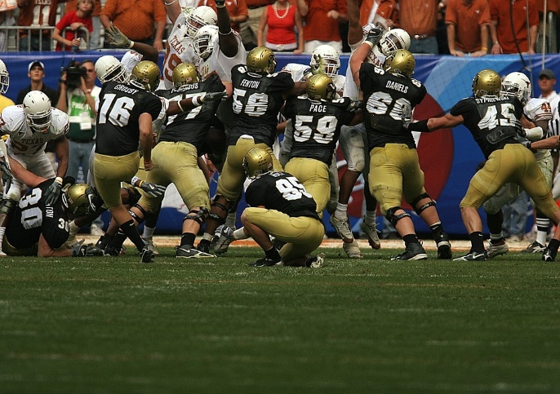A developing part of Braveheart is people who initiate a fundraiser or help make one happen. The Flathead Chamber Players recently performed a benefit concert for us. Thank you to Diane Sine, spouse of Board member Dick Sine, for arranging this event, and to all the Chamber players for their participation.

The Kalispell Police Officers Association is in the process of formalizing a May 20 fundraiser to be held at Flathead Crossfit. This series of athletic challenges will include a 5-K run, a Crossfit “Fran” workout and a Lift Off: Dead Lift Ladder. There will also be the raffling of a variety of items.

So, what has been achieved by this team? Since January 1, a snapshot of my services has included the following:

* Provided support to firefighters after Whitefish Firefighter Ben Parsons was killed in an avalanche.
* Served a family in the emergency room after a toddler was burned in a kitchen accident. Followed up with family.
* Attended Whitefish Police Officer appreciation banquet.
* Responded to 3 motor vehicle accidents, including 2 rollovers.
* Helped a mother and suicidal teen at home and at the hospital. Provided counselor information and did follow up.
* On scene for code call where patient was resuscitated, but later died at the hospital. Assisted roommate who had conducted CPR.
* Assisted with death notification to father whose child died of drug overdose.
* Conducted a debriefing for a youth treatment facility where a student had taken his own life.
* Supported family after a relative died unexpectedly.
* Helped dispatcher after she had a citizen shoot herself while dispatcher was on the phone with her.
* Assisted family on scene where a loved one had a heart attack. Accompanied them to the hospital.
* Responded to 5 death calls in an 8 day period which included a suicide and one death due to hypothermia. Aided coroner with death notification to mother of hypothermic victim. Conducted follow up.

Another integral part of the team is the group of part-time chaplains who share the on-call schedule, respond to scenes and minister to agency personnel. While not an official part of Braveheart, these local pastors serve as volunteers to help provide 24-hour chaplain availability and offer chaplain services to the departments.

Although I may be the one to actually “kick the ball”, many people help make the Braveheart team a reality. I appreciate all of you who are a part of our team.

With gratitude,

Drew

If you would like to receive our future newsletters electronically instead of by regular mail, please send your e-mail address to [chaplaindrew10@gmail.com](mailto:chaplaindrew10@gmail.com). Thank you.